WEEK 1
Input:
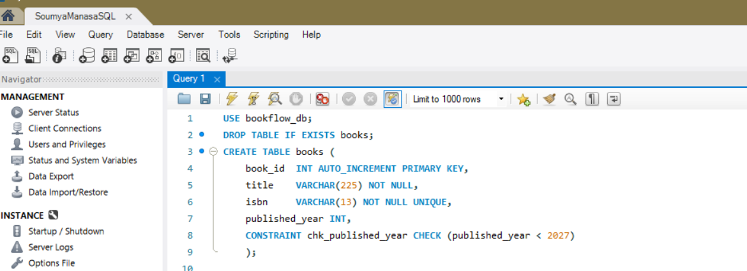

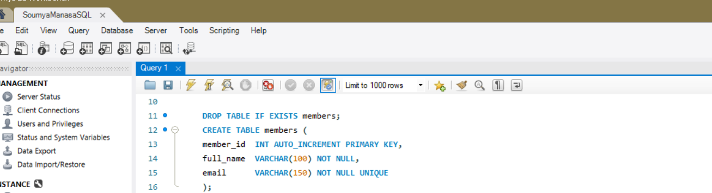

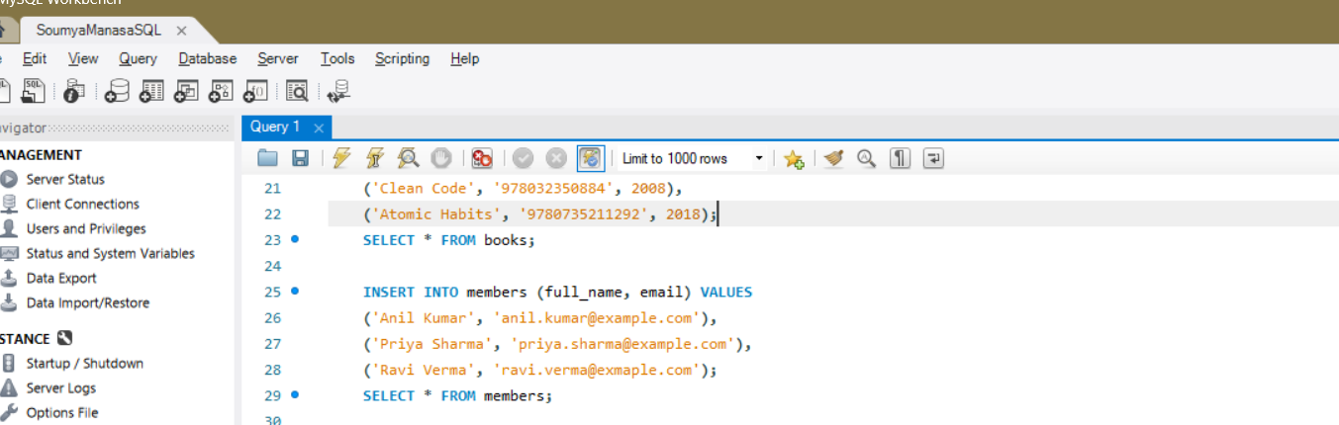

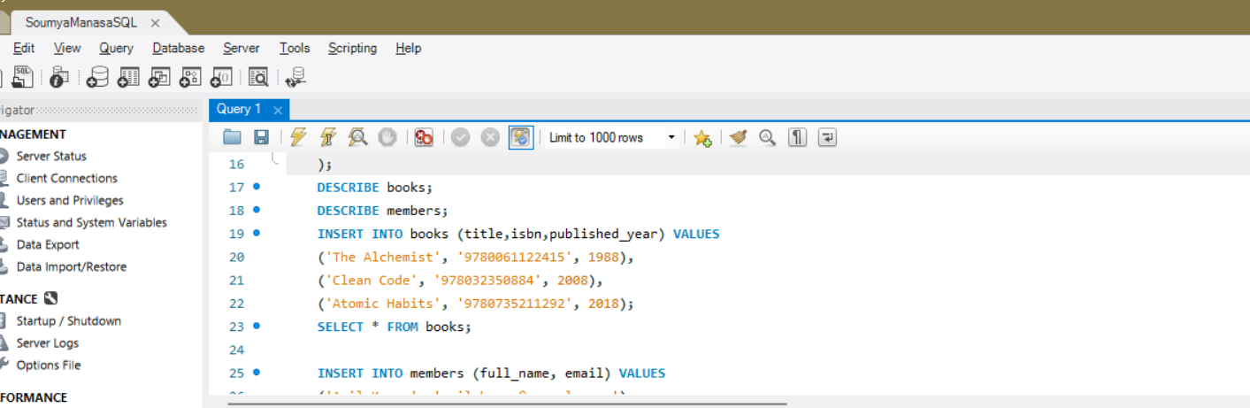

Ouput:
